# CS 255 System Design Document Template

## UML Diagrams

### UML Use Case Diagram

This use case diagram is specifically excluding Login path as those would be the same between all users.

But shows the 4 users and their different goals

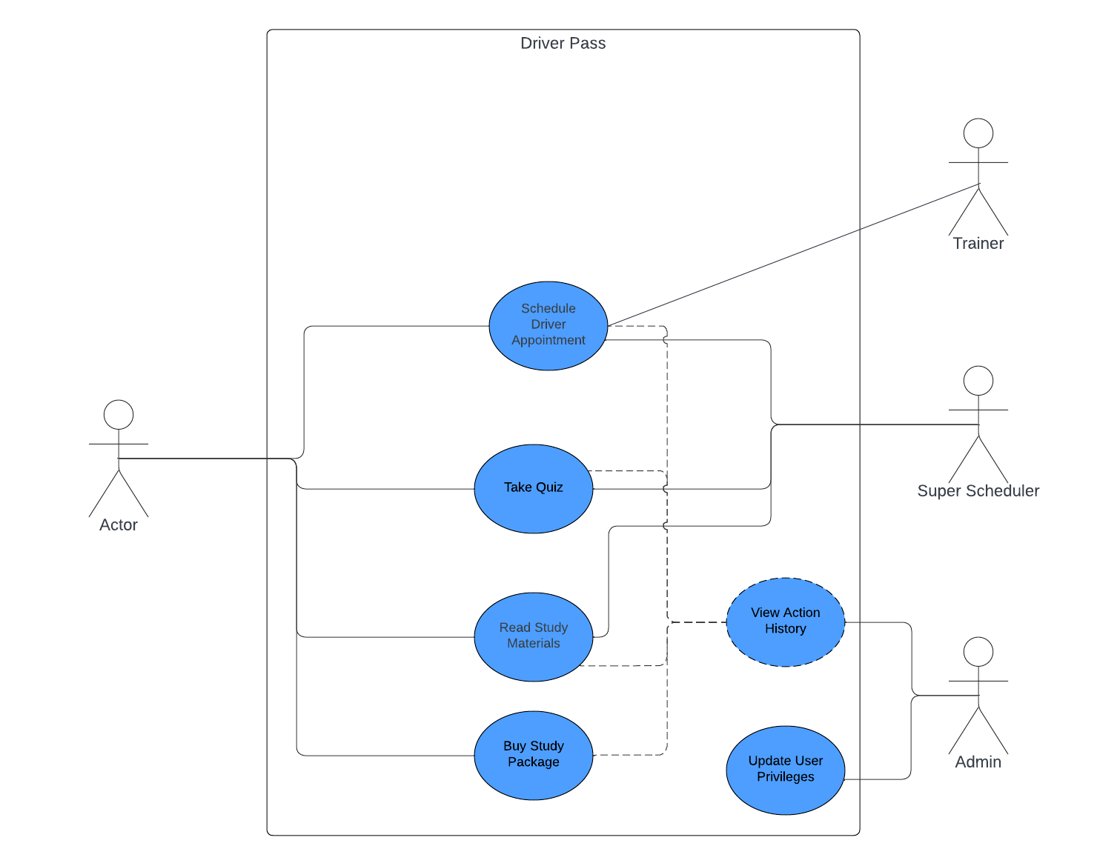

### UML Activity Diagrams

*[You were asked to choose* ***two*** *use cases and create* ***two*** *activity diagrams, one for each use case. Please insert* ***both*** *of your activity diagrams here. Check to make sure that you included appropriate components and symbols and that your design meets the client’s needs.]*

*The diagram on the left dictate the purchase of the different package the diagram on the left dictates how a user would spend those training hours.*

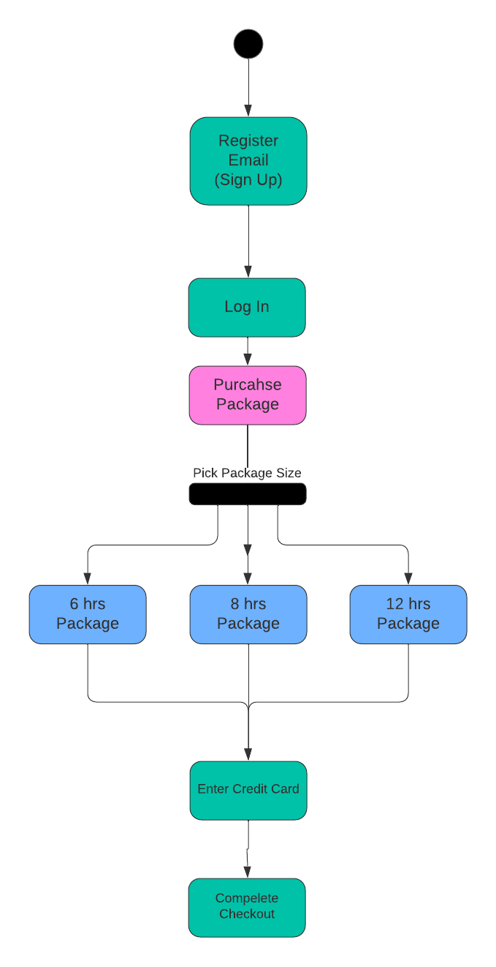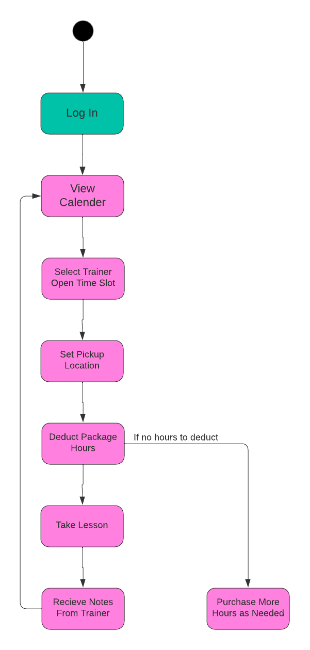

### UML Sequence Diagram

*[You were asked to create a sequence diagram based on* ***one*** *of the use cases you chose. Please insert your sequence diagram here. Check to make sure that you included appropriate components and symbols and that your design meets the client’s needs.]*

The purpose of this diagram is to detail the multiple user interaction with the calender model  
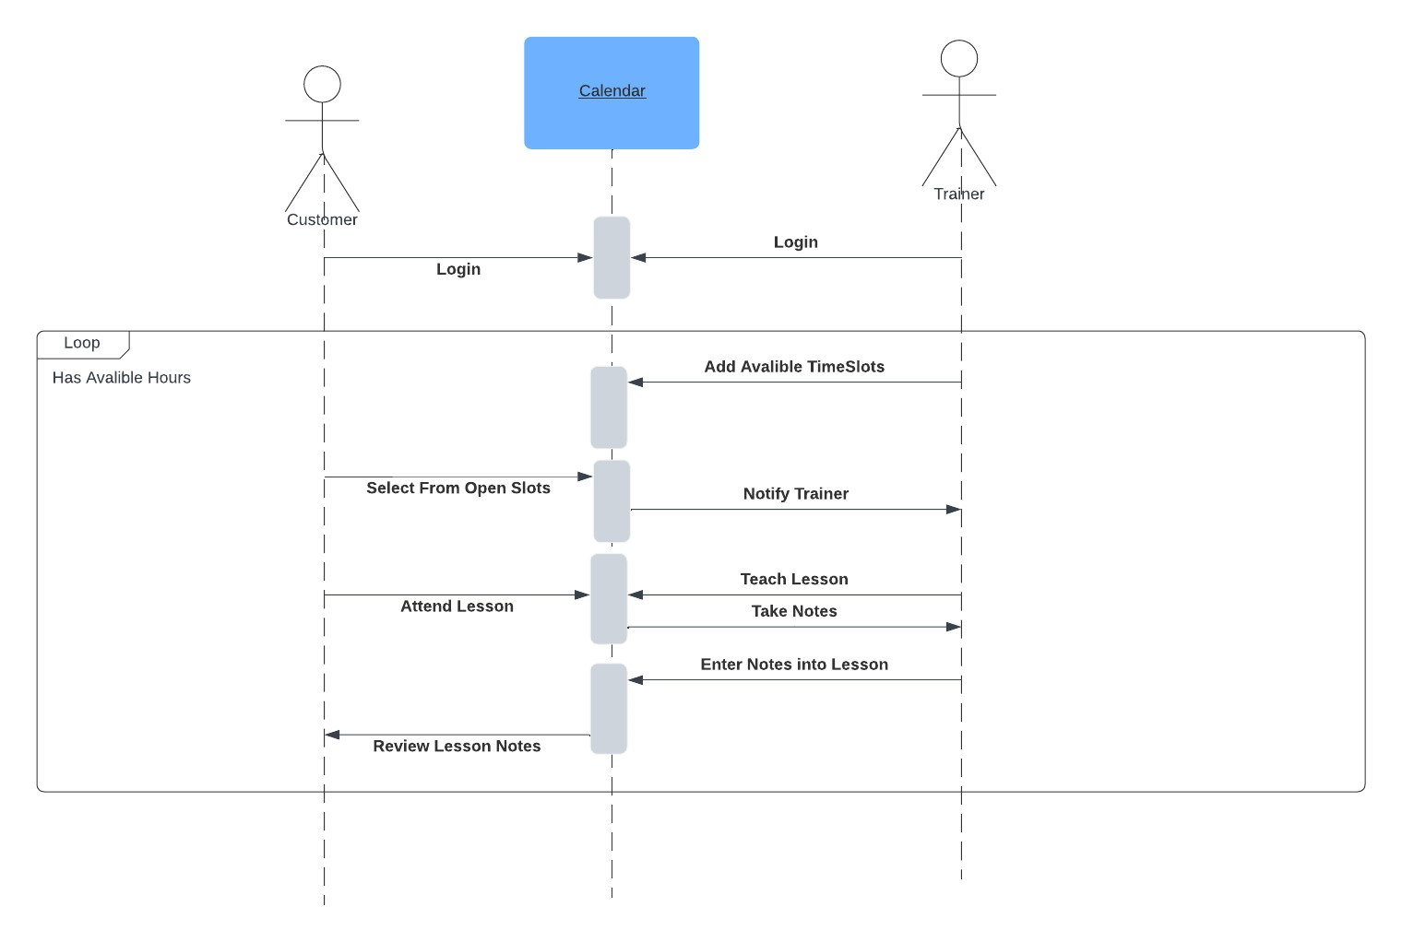

### UML Class Diagram

*[You were asked to create a class diagram based on the different classes and attributes needed for your system design. You are* ***not*** *required to include methods, but you may if you wish. Please insert your class diagram here. Check to make sure that you included appropriate components and symbols and that your design meets the clie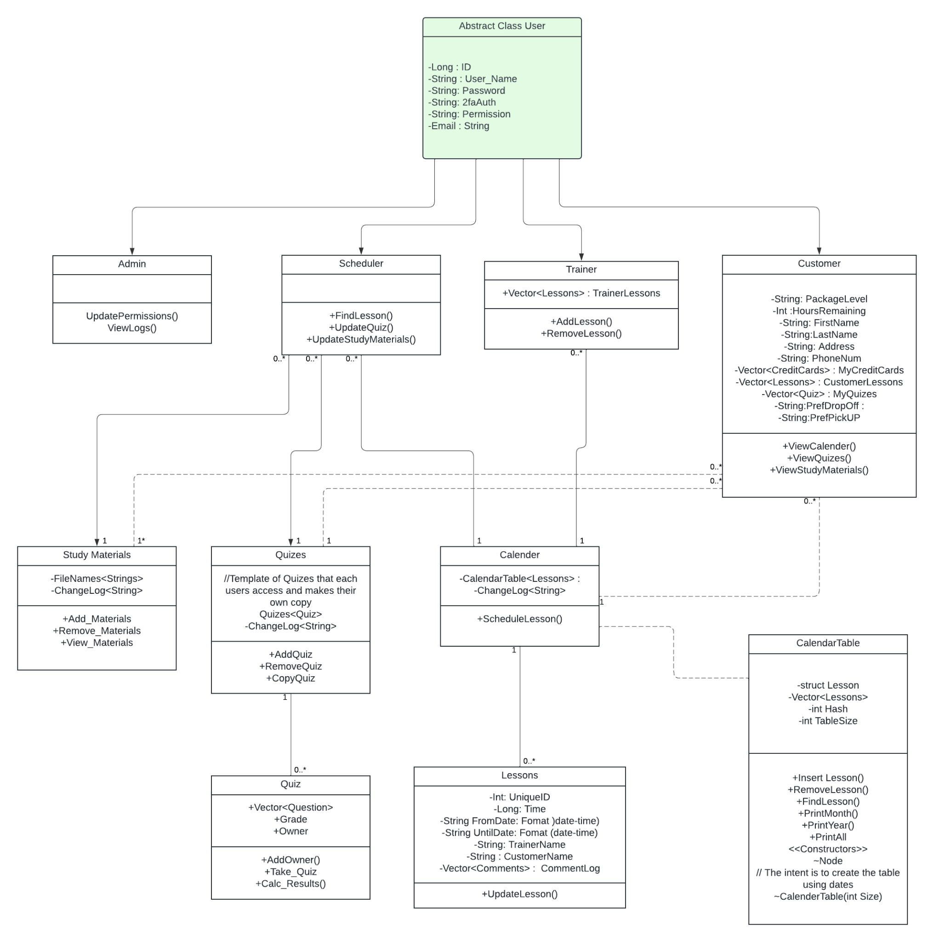nt’s requirements.]*

## Technical Requirements

*[Based on the diagrams you have created, describe the technical requirements of your system. These requirements should address the required hardware, software, tools, and infrastructure necessary for your system design.]*

* You’ll want a Unix based server for the website files to pull forms, as the most inexpensive model and supports all major browsers.
* Third-Party Credit Card security system, paypal and other banking applications.
* You have another partition of the server and service space or database service if one can be found that keeps track of the totality of the customer database. I think a background database as a service is better for scalability with your project so it can be distributed across larger areas easier.
* Website will need a detail oriented UI, this can either be handled by building front-end designer & Developer or done yourself using a website as a service program like wordpress. I recommend full development of the front-end as it will look more unique.